

User Management - User Stories

Contents

1. User story- Login 4
1.1 Mock-ups 5
2. User Story- Logout 6
2.1. Mock-ups 6
3. User Story- Forgot Password 7
3.1 Mock-ups 9
4. User Story- Reset Password 10
4.1 Mock-ups 11
5. User Management- Super Admin-Add an Admin role 12
5.1 Mock-ups 14
6. User Management- Super Admin-Edit a role 15
6.1 Mock-ups 16
7. User Management- Super Admin-View Role 17
7.1 Mock-ups 18
8. User Management- Super Admin- Deactivate/Activate an admin role 19
8.1 Mock-ups 20
9. User Management- Super Admin-Map users 20
9.1 Mock-ups 22
10. User Management- Super Admin-Add a user 23
10.1 Mock-ups 25
11. User Management- Super Admin-Edit a user 25
11.1 Mock-ups 27
12. User Management- Super Admin-View user 27
12.1 Mock-ups 28
13. User Management- Super Admin-View User Roles 29
13.1 Mock-ups 30
14. User Management- Super Admin- Deactivate/Activate a User 30
14.1 Mock-ups 31
15. User Management- Super Admin-Lock/Unlock a user 32
15.1 Mock-ups 33
16. User Management- Admin-Add a role 33
16.1 Mock-ups 35
17. User Management- Admin- Edit a role 36
17.1 Mock-ups 37
18. User Management- Admin-View Role 37
18.1 Mock-ups 39
19. User Management- Admin- Deactivate/Activate a role 39
19.1 Mock-ups 40
20. User Management- Admin-Map role 41
20.1 Mock-ups 42
21. User Management- Admin-Map users 43
21.1 Mock-ups 45
22. User Management- Admin-View Application users 45
22.1 Mock-ups 47
23. User Management- Admin-View user 47
23.1 Mock-ups 48
24. User Management- Admin-Revoke/Grant role to user 49
24.1 Mock-ups 50

Changes

S. No. | Changed Module | Description
1 | 3 | Fields reduced in forgot password form, OTP business rules added.
2 | 3.1 | Forgot password screen changed.
3 | 9 | Technical flow changed in mapping users for a role by super admin.
4 | 9.1 | Layout changed in mapping users for a role by super admin.
5 | 21 | Technical flow changed in mapping users for a role by super admin.
6` | 21.1 | Layout changed in mapping users for a role by admin.

User story- Login

User Story ID | 001
User Story Title | Login
Actors | Organizational/Super Admin, Admins, Users
Story | As a system user I want to login into system.
Pre Conditions | - User should have valid Employee/User ID and password.
Business Criteria | - After login, system home page should be displayed according to the user.  - User’s account got locked after five incorrect attempts.
Acceptance Criteria | - On login screen , user would see the following fields:  - Employee/User ID: Textbox (mandatory).  - Password: Textbox (mandatory).  - User would enter the Employee/User ID and password  - User would click on login button and enter the system.  - In case user enters incorrect credential five times consecutively, user account would be locked. In this case user won’t be allowed to login further and if, user further attempts to login then a pop up message “user account is locked please contact your system administrator” would be displayed to user.  - User would see his home screen after successful login.  Note: All the mandatory fields would be denoted by an *(asterisk). The text “mandatory” and “optional” is just for reference and should not be used in the actual UI. There would also be a key stating that *(asterisk) would mean all mandatory fields. This can be at the top right of the section or at the bottom corner.
Field level Validation | - Employee/User ID: Alphanumeric, maximum 15 characters. Validate from database.  - Password: Alphanumeric with special characters allowed maximum 255 characters. Validate from database. It must contain:  - An uppercase alphabet.  - A lower case alphabet.  - A number.  - A special character.  - Minimum 8 characters long.  Note: All mandatory fields can’t be left blank.

Mock-ups

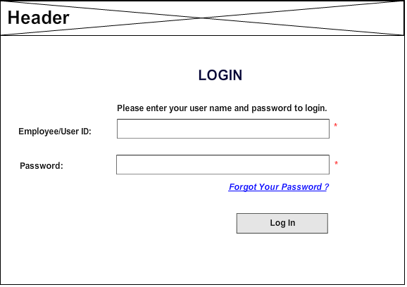

User Story- Logout
User Story ID | 002
User Story Title | Logout
Actors | Organizational Admin, Admins, Users
Story | As a system user I want to logout of the system.
Pre Conditions | - User should be logged in to the system.
Business Criteria | N/A
Acceptance Criteria | - On home screen, user would click on the ‘logout’ option.  - User would be logged out of the system.  - On logout screen there will be an option to login again.
Field Level Validation | N/A

Mock-ups

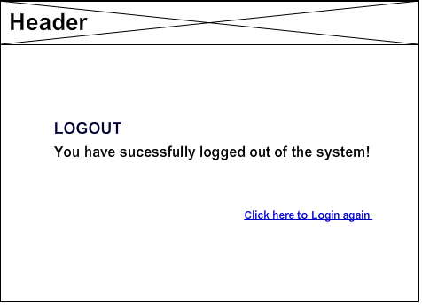

User Story- Forgot Password

User Story ID | 003
User Story Title | Forgot Password
Actors | Admins, Users
Story | As a system user I want to set a new password for login because, I forgot my password.
Pre Conditions | - User should have valid Employee/User ID.
Business Criteria | - Super Admin needs to contact NST in case of ‘forgot password’.  - In case multiple OTP generated, only the latest one would be active and rest would be expired.  - OTP lifecycle would be 10 minutes, after that it would be expired.
Acceptance Criteria | - User would click on ‘forgot password’ option on login screen.  - Screen would display a form containing below fields:  - Employee/User ID: Textbox, Mandatory.  - User would provide his/her Employee/User ID  - User would get a message “Please confirm your mobile number to receive the One Time Password” along with the mobile number in the format xxxxx12345 (last five digits to be displayed). User would select the checkbox and click on ‘Generate OTP’ button to generate OTP or alternatively he would click on ‘cancel’ button to return back to login screen.  - OTP code would be sent to both user’s Mobile number (Registered) and email (registered). User would get the alert message "OTP successfully sent on registered Mobile number and email.”  - Next screen will have the following fields:  - Enter OTP (mandatory)  - User would enter OTP and click on ‘submit’ button to go to the next screen (in case of correct OTP) or alternatively click on ‘cancel’ button to go back to login screen. User can also click on ‘regenerate OTP’ option to regenerate OTP.  - On next screen user would see the following fields:  - New Password: Textbox (mandatory).  - Confirm New Password: Textbox (mandatory).  - User would provide new password two times to confirm and click on ‘submit’ button to save new password or alternatively click on ‘cancel’ button to go back to login screen.  - User would get the alert message “Password changed successfully”.  Note: All the mandatory fields would be denoted by an *(asterisk). The text “mandatory” and “optional” is just for reference and should not be used in the actual UI. There would also be a key stating that *(asterisk) would mean all mandatory fields. This can be at the top right of the section or at the bottom corner.
Field level Validation | - Employee/User ID: Alphanumeric, maximum 15 characters. Validate from database.  - OTP: Numeric, maximum up to 8 digits.  - New Password: Alphanumeric with special characters allowed maximum 255 characters. Validate from database. It must contain:  - An uppercase alphabet.  - A lower case alphabet.  - A number.  - A special character.  - Minimum 8 characters long.  - Confirm New Password: Alphanumeric with special characters allowed maximum 255 characters. Validate from database. It must contain:  - An uppercase alphabet.  - A lower case alphabet.  - A number.  - A special character.  - Minimum 8 characters long.  - Should match with the new password field.  Note: All mandatory fields can’t be left blank.

Mock-ups

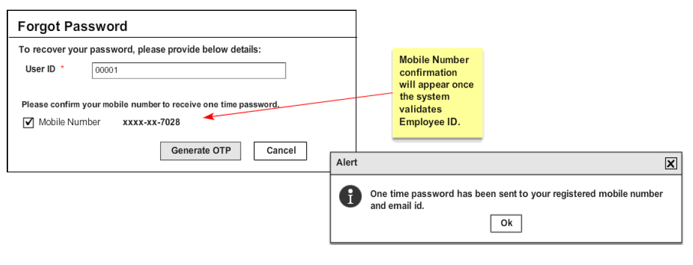

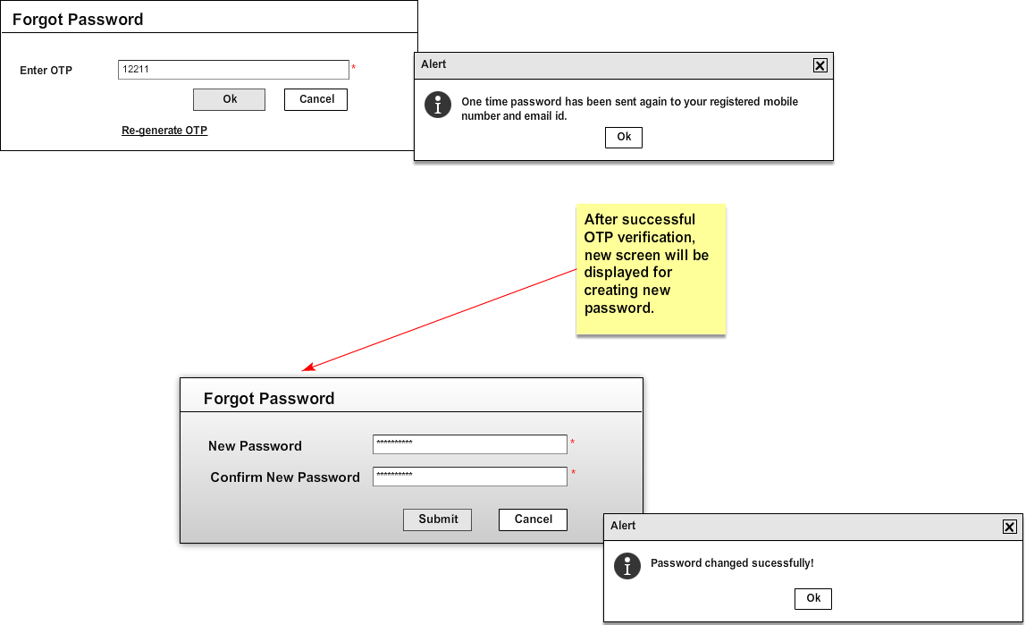

User Story- Reset Password

User Story ID | 004
User Story Title | Reset Password
Actors | Organizational Admin, Admins, Users
Story | As a system user I want to reset my password.
Pre Conditions | - User should be logged in to system.
Business Criteria | - Password reset policy for mandatory change of password in every 90 days.  - New password and current (old) password should not be same.
Acceptance Criteria | - User would click on ‘reset password’ option on home screen.  - Screen would display a form containing below fields:  - Old password: Textbox (mandatory).  - New Password: Textbox (mandatory).  - Confirm New Password: Textbox (mandatory).  - User would provide new password two times to confirm and click on ‘submit’ button to save new password or alternatively click on ‘cancel’ button to go back to home screen.  - System would verify the old password and reset it to new one. User will get the alert message “Password changed successfully”.  Note: All the mandatory fields would be denoted by an *(asterisk). The text “mandatory” and “optional” is just for reference and should not be used in the actual UI. There would also be a key stating that *(asterisk) would mean all mandatory fields. This can be at the top right of the section or at the bottom corner.
Field level Validation | - Old Password: Alphanumeric with special characters allowed maximum 255 characters. Validate from database. It must contain:  - An uppercase alphabet.  - A lower case alphabet.  - A number.  - A special character.  - Minimum 8 characters long.  - New Password: Alphanumeric with special characters allowed maximum 255 characters. Validate from database. It must contain:  - An uppercase alphabet.  - A lower case alphabet.  - A number.  - A special character.  - Minimum 8 characters long.  - Confirm New Password: Alphanumeric with special characters allowed maximum 255 characters. Validate from database. It must contain:  - An uppercase alphabet.  - A lower case alphabet.  - A number.  - A special character.  - Minimum 8 characters long.  - Should match with the new password field.  Note: All mandatory fields can’t be left blank.

Mock-ups

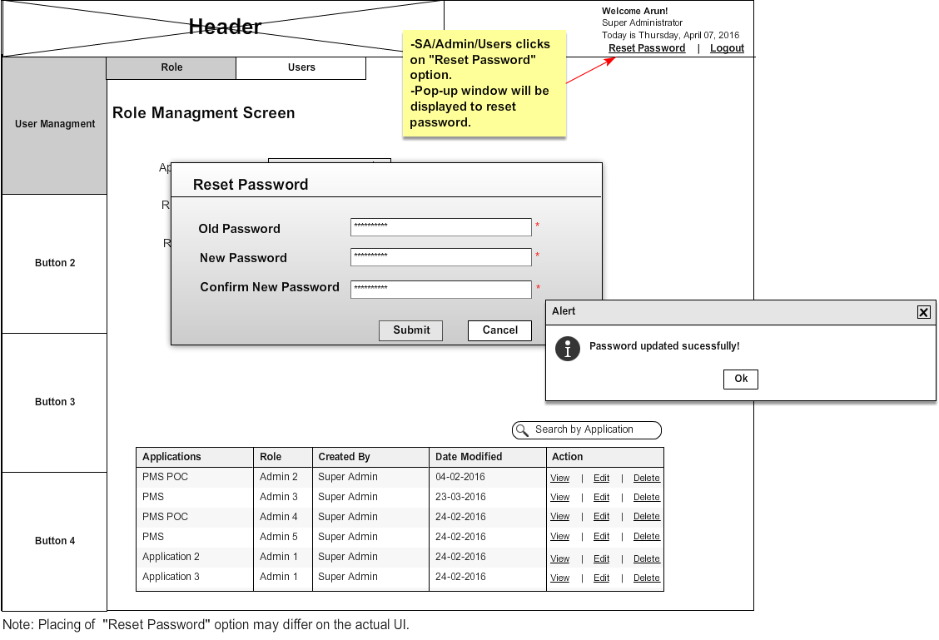

User Management- Super Admin-Add an Admin role

User Story ID | 005
User Story Title | User Management- Super Admin- Add an Admin role
Actors | Super Admin/Organizational Admin
Story | As an Organizational Admin I want to create an admin role for the application(s)
Pre-Conditions | Organizational Admin should be logged into the system.
Business Criteria | - Organizational Admin would create and manage Admin roles (local application admins).  - Organizational Admin would create and manage all users.  - There would be only one admin role per application. In other words admin roles would have one to one relation with applications.  - One user can be mapped to multiple admin roles. In other words users would have many to one relation with admin roles.  - All admin roles created by organizational admin would have complete access on their respective application(s) (including user management) by default.
Acceptance criteria | - Organizational Admin would click on ‘Roles’ tab under ‘User management’ option in home screen for managing roles. The screen will contain a form to add new role along with the list of roles already created.  - The form will contain following fields:  - Application: A drop down with the list of applications (mandatory).  - Role Name: Textbox (mandatory).  - Role Description: Text Area (mandatory).  - Organizational Admin would select the application from the drop down list for which the role is to be created.  - Organizational Admin would enter the role name.  - Organizational Admin would enter the role description.  - Organizational Admin would click on Add button to create a new role or alternatively ‘clear’ button to clear the form data.  - Once Organizational Admin successfully added a role he would get a window popup saying “Role added successfully” and newly added role will be reflected in the list (grid) on the same screen.  - List (grid) will contain the following columns with information:  - Application Name (sorting filter).  - Role Name (sorting filter).  - Created by (sorting filter).  - Date Modified (sorting filter).  - Actions: with ‘Map User’, ’View’, ‘Edit’, ‘Deactivate/Activate’ options.  - Role description should be displayed in a comment box when mouse hovers on a role in the grid list.  Note: All the mandatory fields would be denoted by an *(asterisk). The text “mandatory” and “optional” is just for reference and should not be used in the actual UI. There would also be a key stating that *(asterisk) would mean all mandatory fields. This can be at the top right of the section or at the bottom corner.
Field level Validations | - Role Name: alphanumeric with only space as special character, maximum 150 characters. Validate for unique role name.  - Role description: Text, maximum 500 characters.  Note: All mandatory fields can’t be left blank.

Mock-ups

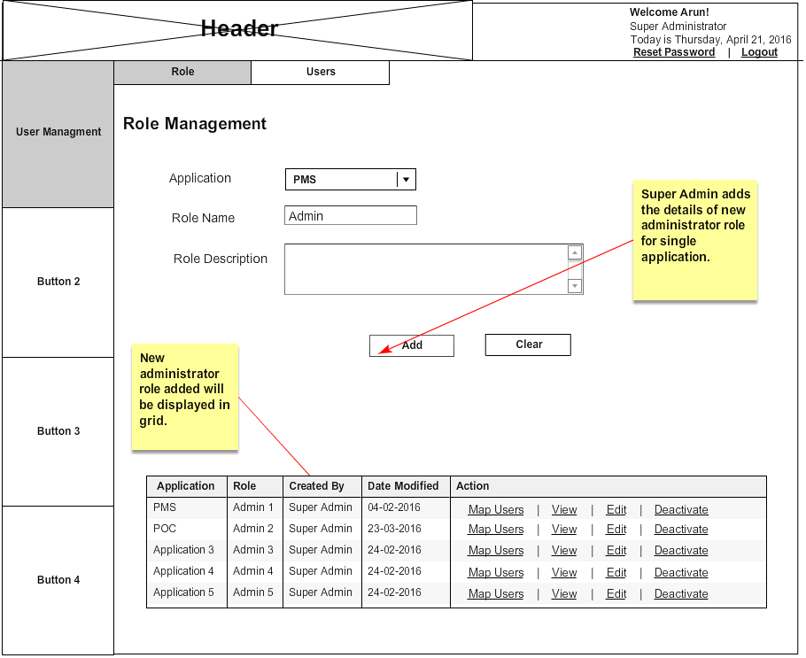

User Management- Super Admin-Edit a role

User Story ID | 006
User Story Title | User Management- Super Admin- Edit a role
Actors | Super Admin/Organizational Admin
Story | As an Organizational Admin I want to edit an admin role so that I can make changes in it.
Pre-Conditions | Organizational Admin should be logged into the system.
Business Criteria | - Organizational Admin would create and manage Admin roles (local application admins).  - Organizational Admin would create and manage all users.  - There would be only one admin role per application. In other words admin roles would have one to one relation with applications.  - One user can be mapped to multiple admin roles. In other words users would have many to one relation with admin roles.  - All admin roles created by organizational admin would have complete access on their respective application(s) (including user management) by default.
Acceptance criteria | - Organizational Admin would click on the ‘Edit’ option for a role from the list of options available in the grid and edit form will appear on the same screen with the existing details.  - Application(s): A drop down check box with the list of applications.  - Role Name: Textbox.  - Role Description: Text Area.  - Organizational Admin would change desired fields and clicks on “OK” button, he would get a window popup saying “Role updated successfully” and control will redirect to the ‘Roles’ tab screen. If he clicks on ‘cancel’ button control would return to the ‘roles’ tab without making any changes.  Note: All the mandatory fields would be denoted by an *(asterisk). The text “mandatory” and “optional” is just for reference and should not be used in the actual UI. There would also be a key stating that *(asterisk) would mean all mandatory fields. This can be at the top right of the section or at the bottom corner.
Field level Validations | - Role Name: alphanumeric with only space as special character, maximum 150 characters. Validate for unique role name.  - Role description: Text, maximum 500 characters.

Mock-ups

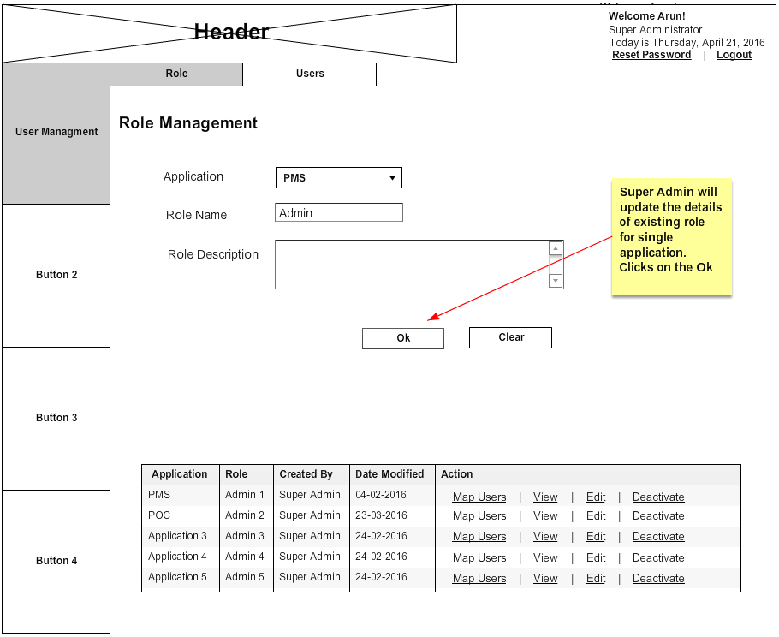

User Management- Super Admin-View Role

User Story ID | 007
User Story Title | User Management- Super Admin- View details of a role
Actors | Super Admin/Organizational Admin
Story | As an Organizational Admin I want to view details of a role.
Pre-Conditions | Organizational Admin should be logged into the system.
Business Criteria | - Organizational Admin would create and manage Admin roles (local application admins).  - Organizational Admin would create and manage all users.  - There would be only one admin role per application. In other words admin roles would have one to one relation with applications.  - One user can be mapped to multiple admin roles. In other words users would have many to one relation with admin roles.  - All admin roles created by organizational admin would have complete access on their respective application(s) (including user management) by default.
Acceptance criteria | - Organizational Admin click on ‘view’ option for a role from the list of options available in the grid and all information about the role will be displayed in a popup window.  - Application.  - Role Name.  - Role description.  - User would click on ‘OK’ button and flow will return to the ‘Roles’ tab.
Field level Validations | N/A

Mock-ups

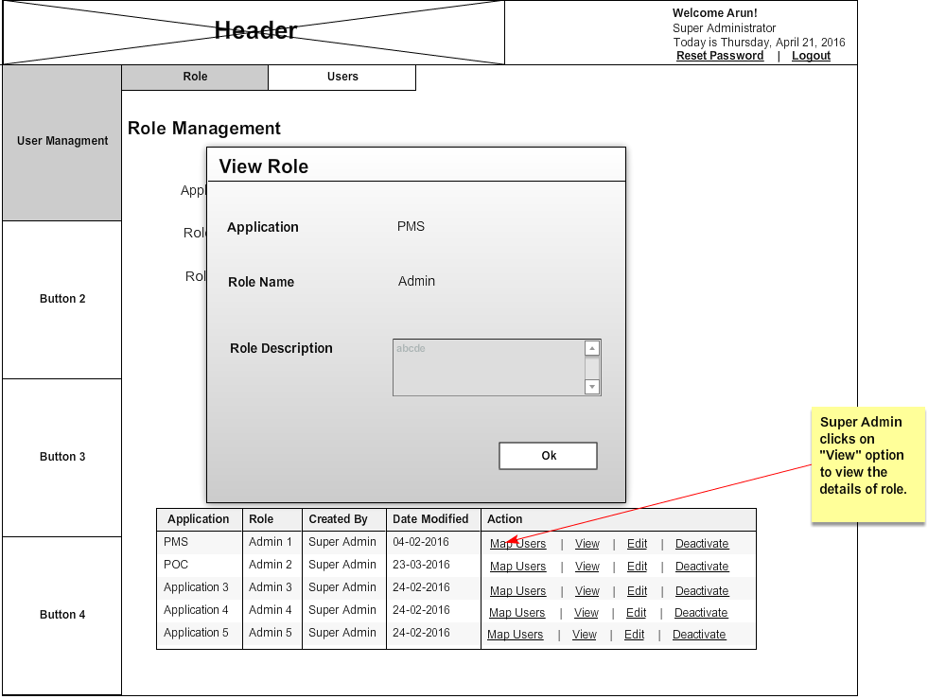

User Management- Super Admin- Deactivate/Activate an admin role

User Story ID | 008
User Story Title | User Management- Super Admin- Deactivate/Activate an admin role
Actors | Super Admin/Organizational Admin
Story | As an Organizational Admin I want to activate/deactivate admin roles.
Pre-Conditions | Organizational Admin should be logged into the system.
Business Criteria | - Organizational Admin would create and manage Admin roles (local application admins).  - Organizational Admin would create and manage all users.  - There would be only one admin role per application. In other words admin roles would have one to one relation with applications.  - One user can be mapped to multiple admin roles. In other words users would have many to one relation with admin roles.  - All admin roles created by organizational admin would have complete access on their respective application(s) (including user management) by default.
Acceptance criteria | - Organizational Admin would select ‘Activate/Deactivate’ option to activate or deactivate a role from the list of options available in the grid.  - Organizational Admin would click on ‘Activate’ option to activate role and ‘Deactivate’ option to deactivate the role. If a role is activated then ‘Deactivate’ option should be displayed and vice versa.
Field level Validations | N/A

Mock-ups

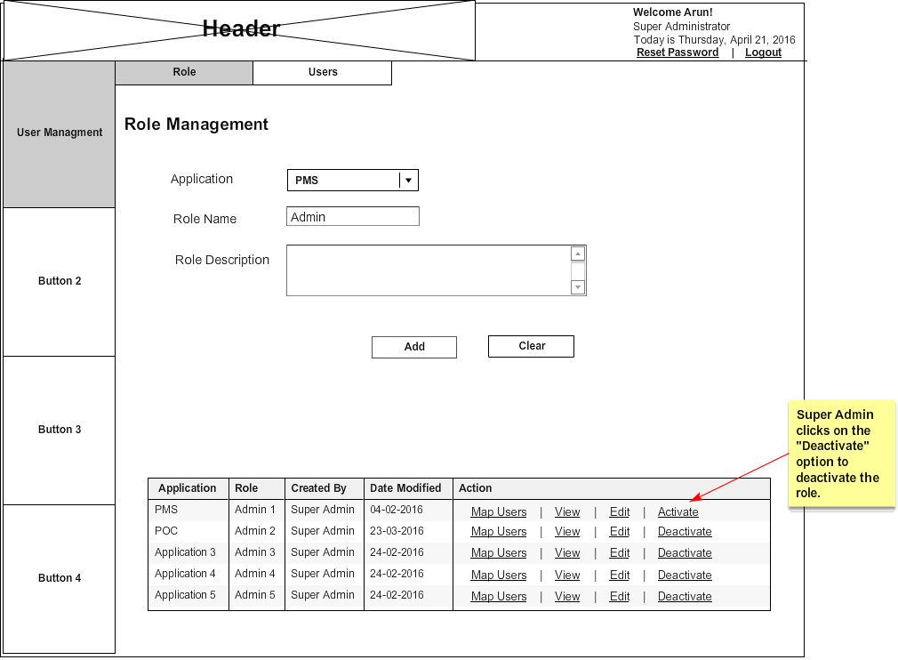

User Management- Super Admin-Map users

User Story ID | 009
User Story Title | User Management- Super Admin- Map users
Actors | Super Admin/Organizational Admin
Story | As an Organizational Admin I want to map users to a role
Pre-Conditions | Organizational Admin should be logged into the system.
Business Criteria | - Organizational Admin would create and manage Admin roles (local application admins).  - Organizational Admin would create and manage all users.  - There would be only one admin role per application. In other words admin roles would have one to one relation with applications.  - One user can be mapped to multiple admin roles. In other words users would have many to one relation with admin roles.  - All admin roles created by organizational admin would have complete access on their respective application(s) (including user management) by default.
Acceptance criteria | - Organizational Admin would select ‘map users’ option from the list of options available in the grid to do user mapping of a particular role.  - Once admin click on ‘map users’ option a screen should be displayed, which contains:  - All users in a grid with ‘add’ option  - A dropdown for selecting roles. By default this will be the selected role from the map user grid which can be further changed to other roles  - Grid for users, mapped to a role  - All users grid will display the following information for the user:  - Employee Id/User Name  - First Name  - Last Name  - Mobile  - Email  - Department  - Created by  - Last Modified  - Action ‘Add’  - Organizational Admin would click on the ‘Add’ option from the grid to map user to this role.  - All mapped users for this role will be displayed in a grid which contains following information:  - Employee Id/User Name  - First Name  - Last Name  - Mobile  - Email  - Department  - Created by  - Last modified  - Action ‘Remove’  - Admin can click on the ‘Remove’ option from the grid to un-map/remove the respective user from the list for this particular role.
Field level Validations

Mock-ups

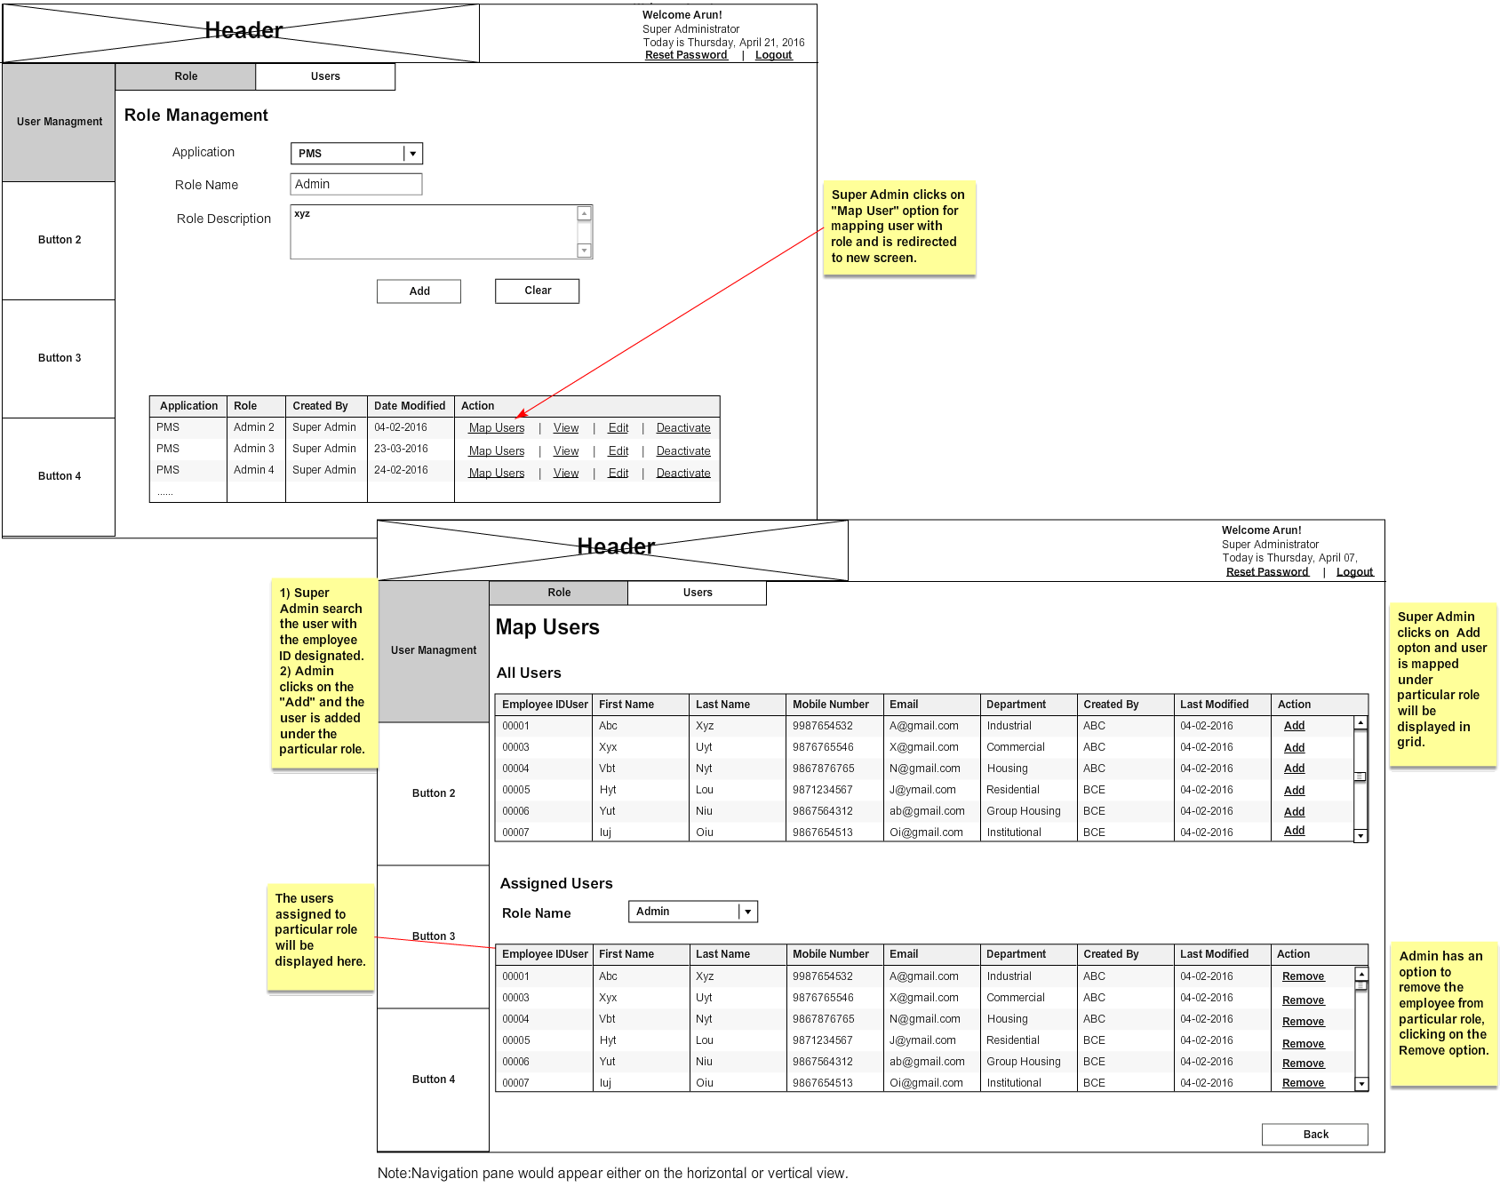

User Management- Super Admin-Add a user

User Story ID | 0010
User Story Title | User Management- Super Admin- Add a user
Actors | Super Admin/Organizational Admin
Story | As an Organizational Admin I want add a user into the system to assign admin roles.
Pre-Conditions | Organizational Admin should be logged into the system.
Business Criteria | - Organizational Admin would create and manage Admin roles (local application admins).  - Organizational Admin would create and manage all users.  - There would be only one admin role per application. In other words admin roles would have one to one relation with applications.  - One user can be mapped to multiple admin roles. In other words users would have many to one relation with admin roles.  - All admin roles created by organizational admin would have complete access on their respective application(s) (including user management) by default.  - Password would be auto generated for new users created.
Acceptance criteria | - Organizational Admin would click on ‘Users’ tab under user management option in home screen for managing users. The screen will contain a form to add new user along with list of users already created. The form will contain the following fields:  - Employee/User ID: Textbox (mandatory).  - First Name: Textbox (mandatory).  - Middle Name: Textbox (optional).  - Last Name: Textbox (mandatory).  - Department: Dropdown checkbox with list of departments (mandatory).  - Mobile number: Textbox (mandatory).  - Email: Textbox (optional).  - Comments: Textbox (optional).  - Organizational Admin would click on ‘Add’ button to create a new user or alternatively on ‘clear’ button to clear the form data.  - Once Organizational Admin successfully added a user he would get a window popup saying “Role added successfully” along with a system generated password for the user and newly added user will be reflected in the list (grid) on the same screen.  - List (grid) will contain the following columns with information:  - Employee/User ID (sorting filter).  - First Name (sorting filter).  - Last Name (sorting filter).  - Mobile number (sorting filter).  - Email (sorting filter).  - Department (sorting filter).  - Created by (sorting filter)  - Date Modified (sorting filter).  - Actions: ‘view user’, ‘view user roles’, ‘Edit’, ‘Lock/Unlock’, ‘Deactivate/Activate’ options.  Note: All the mandatory fields would be denoted by an *(asterisk). The text “mandatory” and “optional” is just for reference and should not be used in the actual UI. There would also be a key stating that *(asterisk) would mean all mandatory fields. This can be at the top right of the section or at the bottom corner.
Field level Validations | - First Name: Text, maximum 100 characters.  - Middle Name: Text, maximum 100 characters.  - Last Name: Text, maximum 100 characters.  - Mobile number: Numeric, fixed 10 digits. Validate for already exist Mobile number, Mobile number should not start with ‘0’.  - Email: Alphanumeric with special characters (‘_’, ‘@’, ‘.’, ‘$’), maximum 150 characters, should be validated with the format abc@xyz.com. Alphanumeric characters include (A-Z, a-z, 0-9). Validate for already exist email.  - Employee/User ID: Alphanumeric, maximum 15 characters. Validate for already exist Employee/User ID. Alphanumeric characters include (A-Z, a-z, 0-9).  - Comments: Text, maximum 255 characters.  Note: All mandatory fields can’t be left blank.

Mock-ups

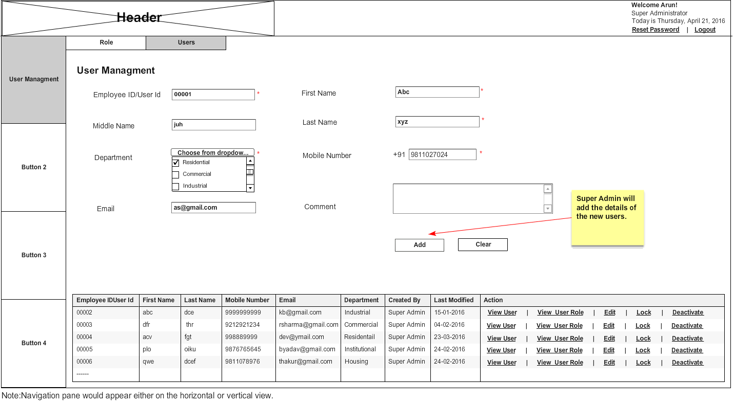

User Management- Super Admin-Edit a user

User Story ID | 0011
User Story Title | User Management- Super Admin- Edit a user
Actors | Super Admin/Organizational Admin
Story | As an Organizational Admin I want to edit a user details so that I can make changes in it.
Pre-Conditions | Organizational Admin should be logged into the system.
Business Criteria | - Organizational Admin would create and manage Admin roles (local application admins).  - Organizational Admin would create and manage all users.  - There would be only one admin role per application. In other words admin roles would have one to one relation with applications.  - One user can be mapped to multiple admin roles. In other words users would have many to one relation with admin roles.  - All admin roles created by organizational admin would have complete access on their respective application(s) (including user management) by default.  - Password would be auto generated for new users created.
Acceptance criteria | - Organizational Admin would click on the ‘Edit’ option for a user from the list of options available in the grid and edit form will appear on the same screen with the existing details.  - Employee/User ID: Textbox (mandatory).  - First Name: Textbox (mandatory).  - Middle Name: Textbox (optional)  - Last Name: Textbox (mandatory).  - Department: Dropdown checkbox with list of departments (mandatory).  - Mobile number: Textbox (mandatory).  - Email: Textbox (optional).  - Comments: Textbox (optional).  - Organizational Admin would change desired fields and clicks on “OK” button, he would get a window popup saying “user updated successfully” and control will redirect to the ‘Users’ tab screen. If he clicks on ‘cancel’ button control would return to the ‘Users’ tab without making any changes.  Note: All the mandatory fields would be denoted by an *(asterisk). The text “mandatory” and “optional” is just for reference and should not be used in the actual UI. There would also be a key stating that *(asterisk) would mean all mandatory fields. This can be at the top right of the section or at the bottom corner.
Field level Validations | - First Name: Text, maximum 100 characters.  - Middle Name: Text, maximum 100 characters.  - Last Name: Text, maximum 100 characters.  - Mobile number: Numeric, fixed 10 digits. Validate for already exist Mobile number, Mobile number should not start with ‘0’.  - Email: Alphanumeric with special characters (‘_’, ‘@’, ‘.’, ‘$’), maximum 150 characters, should be validated with the format abc@xyz.com. Alphanumeric characters include (A-Z, a-z, 0-9). Validate for already exist email.  - Employee/User ID: Alphanumeric, maximum 15 characters. Validate for already exist Employee/User ID. Alphanumeric characters include (A-Z, a-z, 0-9).  Comments: Text, maximum 255 characters.  Note: All mandatory fields can’t be left blank.

Mock-ups

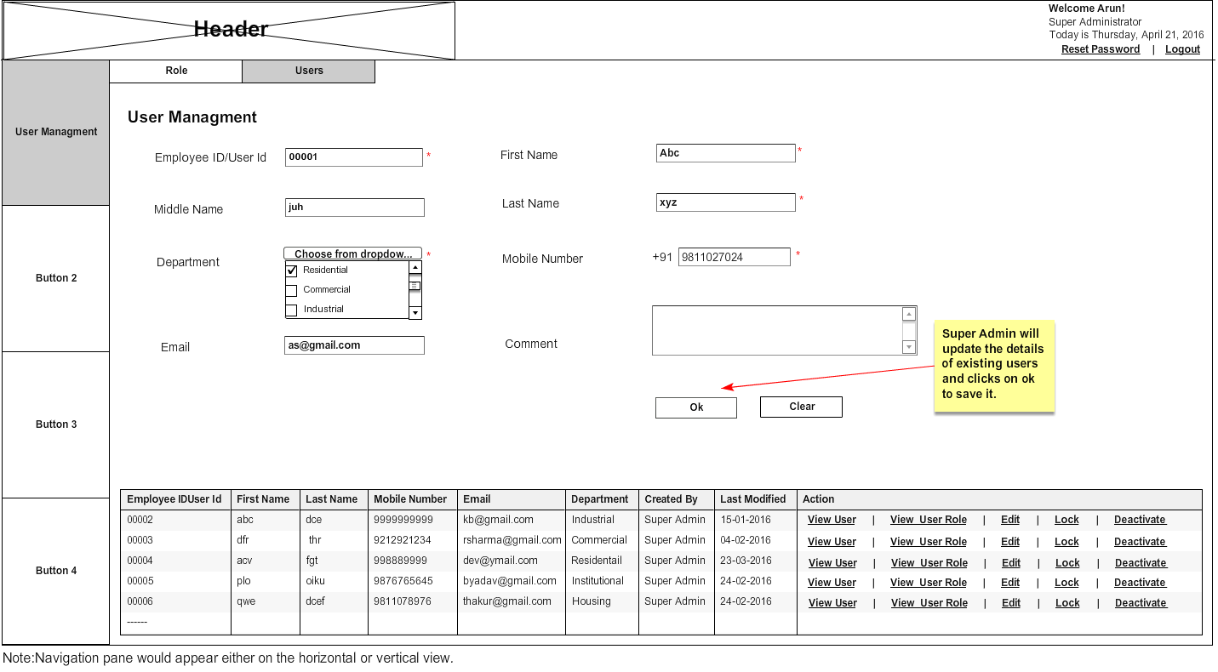

User Management- Super Admin-View user

User Story ID | 0012
User Story Title | User Management- Super Admin- View details of a user.
Actors | Super Admin/Organizational Admin.
Story | As an Organizational Admin I want to view details of a user.
Pre-Conditions | Organizational Admin should be logged into the system.
Business Criteria | - Organizational Admin would create and manage Admin roles (local application admins).  - Organizational Admin would create and manage all users.  - There would be only one admin role per application. In other words admin roles would have one to one relation with applications.  - One user can be mapped to multiple admin roles. In other words users would have many to one relation with admin roles.  - All admin roles created by organizational admin would have complete access on their respective application(s) (including user management) by default.  - Password would be auto generated for new users created.
Acceptance criteria | - Organizational Admin click on ‘view’ option for a user from the list of options available in the grid and all information about the role will be displayed in a popup window.  - Employee/User ID (auto generated, unique).  - First Name.  - Middle Name.  - Last Name.  - Department.  - Mobile number.  - Email.  - Comment.  - User would click on ‘OK’ button and flow will return to the ‘Users’ tab.
Field level Validations | N/A

Mock-ups

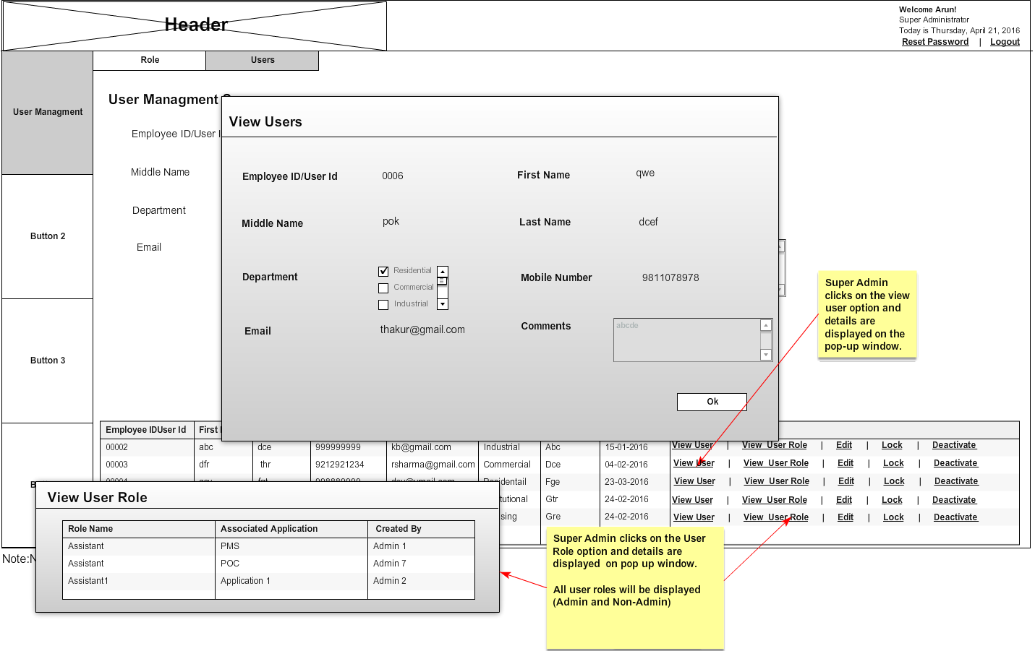

User Management- Super Admin-View User Roles
User Story ID | 0013
User Story Title | User Management- Super Admin- View user roles.
Actors | Super Admin
Story | As an Super Admin I want to view user’s roles
Pre-Conditions | Super Admin should be logged into the system.
Business Criteria | - Organizational Admin would create and manage Admin roles (local application admins).  - Organizational Admin would create and manage all users.  - There would be only one admin role per application. In other words admin roles would have one to one relation with applications.  - One user can be mapped to multiple admin roles. In other words users would have many to one relation with admin roles.  - All admin roles created by organizational admin would have complete access on their respective application(s) (including user management) by default.
Acceptance criteria | - Organizational Admin would click on ‘view user roles’ option for a user from the list of options available in the grid and all information(in a grid or tabular format) about the roles and associated applications for the user will be displayed in a popup window. Columns of the table would be:  - Role Name.  - Associated Applications  - Created By.  - User would click on ‘OK’ button and flow will return to the ‘Users’ tab.
Field level Validations | N/A

Mock-ups

User Management- Super Admin- Deactivate/Activate a User

User Story ID | 0014
User Story Title | User Management- Super Admin- Deactivate/Activate a user
Actors | Super Admin/Organizational Admin
Story | As an Organizational Admin I want to activate/deactivate a user
Pre-Conditions | Organizational Admin should be logged into the system.
Business Criteria | - Organizational Admin would create and manage Admin roles (local application admins).  - Organizational Admin would create and manage all users.  - There would be only one admin role per application. In other words admin roles would have one to one relation with applications.  - One user can be mapped to multiple admin roles. In other words users would have many to one relation with admin roles.  - All admin roles created by organizational admin would have complete access on their respective application(s) (including user management) by default.
Acceptance criteria | - Organizational Admin would select ‘Activate/Deactivate’ option to activate or deactivate a user from the list of options available in the grid.  - Organizational Admin would click on ‘Activate’ option to activate user and ‘Deactivate’ option to deactivate the user. If a user is activated then ‘Deactivate’ option should be displayed and vice versa.
Field level Validations | N/A

Mock-ups

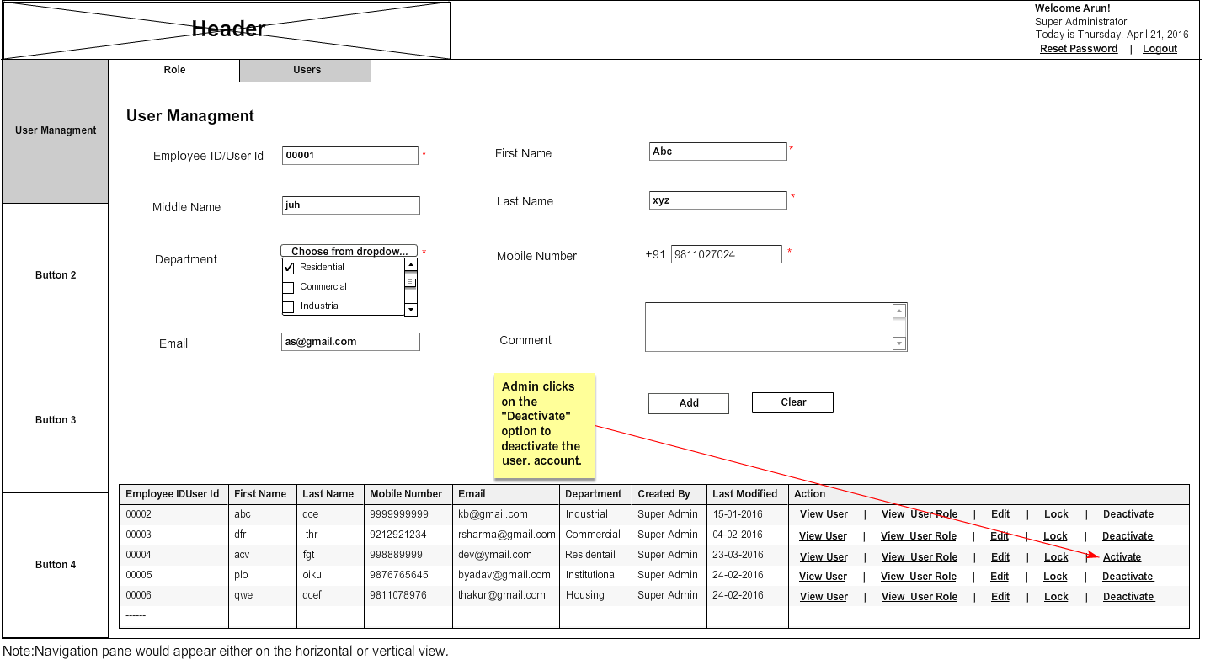

User Management- Super Admin-Lock/Unlock a user

User Story ID | 0015
User Story Title | User Management- Super Admin- lock/unlock a user
Actors | Super Admin/Organizational Admin
Story | As an Organizational Admin I want to lock/unlock a user.
Pre-Conditions | Organizational Admin should be logged into the system.
Business Criteria | - Organizational Admin would create and manage Admin roles (local application admins).  - Organizational Admin would create and manage all users.  - There would be only one admin role per application. In other words admin roles would have one to one relation with applications.  - One user can be mapped to multiple admin roles. In other words users would have many to one relation with admin roles.  - All admin roles created by organizational admin would have complete access on their respective application(s) (including user management) by default.  - Password would be auto generated for new users created.  - After five incorrect login attempts user account would be locked automatically.
Acceptance criteria | - Organizational Admin would select ‘lock/unlock’ option to lock or unlock a user from the list of options available in the grid.  - Organizational Admin would click on ‘lock’ option to lock user and ‘unlock’ option to unlock the user. If a role is locked then ‘unlock’ option should be displayed and vice versa.
Field level Validations | N/A

Mock-ups

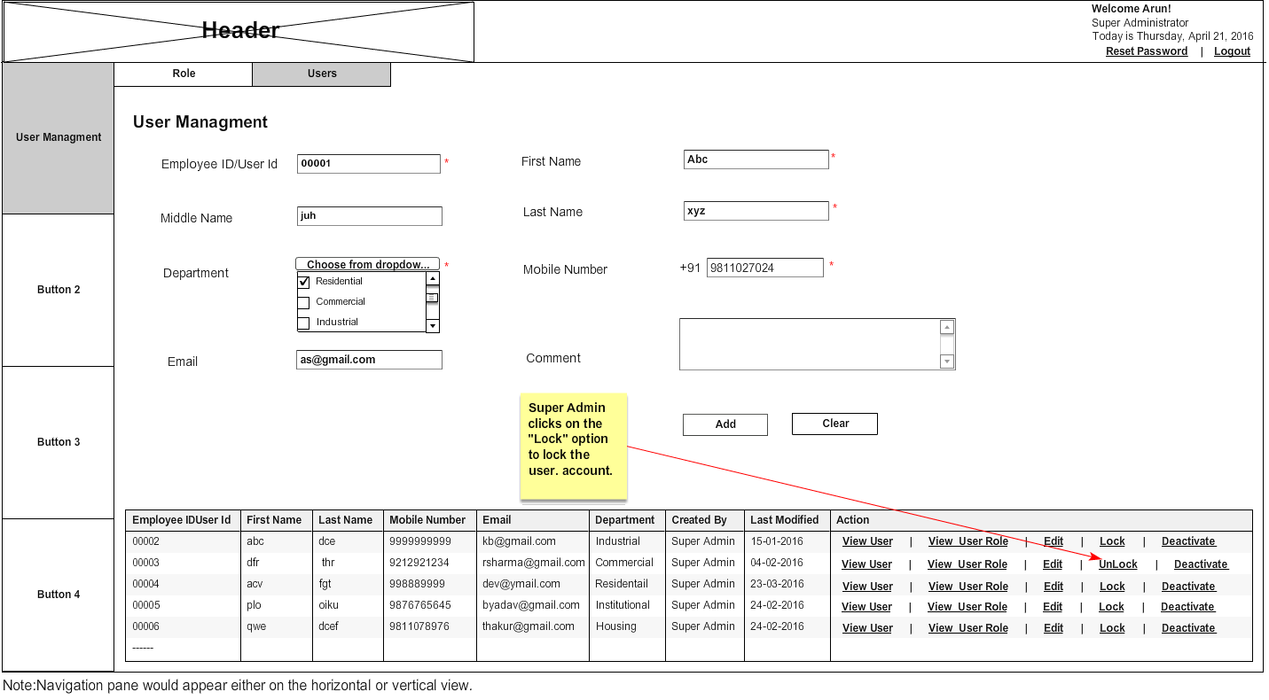

User Management- Admin-Add a role

User Story ID | 0016
User Story Title | User Management- Admin- Add a role
Actors | Admin
Story | As an Admin I want to create a role for the application.
Pre-Conditions | Admin should be logged into the system.
Business Criteria | - Admin cannot create another admin user or role.  - Only those applications should be visible in creating a role for which the admin has access rights.  - Menu mapping of roles doesn’t include user management menus. Alternatively, admin would not be able to give access for user management to other users.  - In case an application has more than one admin then, any roles or users created by one admin would be displayed to all admins of the application.  - In case an application has more than one admin then, all admins would have same rights on users and roles of the application.  - One user will have one role in an application.  - A user can be given access for multiple applications.  - Admin would see the users of its application(s) along with the roles.
Acceptance criteria | - Admin would click on ‘Roles’ tab under ‘User management’ option in home screen for managing roles. The screen will contain a form to add new role along with the list of roles already created.  - The form will contain following fields:  - Application: A dropdown list of applications (mandatory).  - Role Name: Textbox (mandatory).  - Role Description: Text Area (mandatory).  - Admin would select the application from the drop down list for which the role is to be created.  - Admin would enter the role name.  - Admin would enter the role description.  - Admin would click on Add button to create a new role or alternatively ‘clear’ button to clear the form data.  - Once Admin successfully added a role he would get a window popup saying “Role added successfully” and newly added role will be reflected in the list (grid) on the same screen.  - List (grid) will contain the following columns with information:  - Application Name (sorting filter).  - Role Name (sorting filter).  - Created by (sorting filter).  - Date Modified (sorting filter).  - Menu Mapping: ‘Map role’ option.  - User Mapping: ‘Map users’ option.  - Actions: with ’View’, ‘Edit’, ‘Deactivate/Activate’ options.  - Role description should be displayed in a comment box when mouse hovers on a role in the grid list.  Note: All the mandatory fields would be denoted by an *(asterisk). The text “mandatory” and “optional” is just for reference and should not be used in the actual UI. There would also be a key stating that *(asterisk) would mean all mandatory fields. This can be at the top right of the section or at the bottom corner.
Field level Validations | - Role Name: alphanumeric with only space as special character, maximum 150 characters. Validate for unique role name.  - Role description: Text, maximum 500 characters.  Note: All mandatory fields can’t be left blank.

Mock-ups

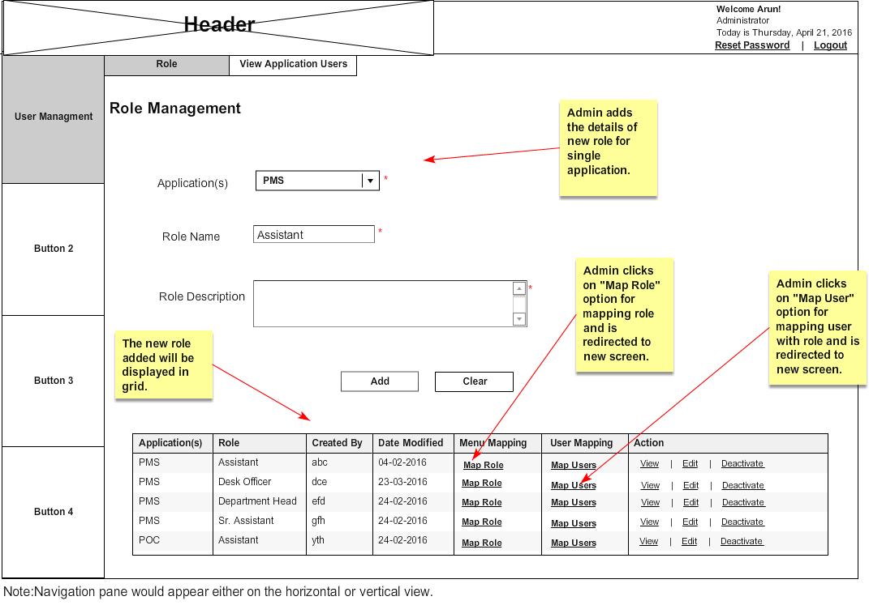

User Management- Admin- Edit a role

User Story ID | 0017
User Story Title | User Management- Admin- Edit a role
Actors | Admin
Story | As an Admin I want to edit a role so that I can make changes in it.
Pre-Conditions | Admin should be logged into the system.
Business Criteria | - Admin cannot create another admin user or role.  - Only those applications should be visible in creating a role for which the admin has access rights.  - Menu mapping of roles doesn’t include user management menus. Alternatively, admin would not be able to give access for user management to other users.  - In case an application has more than one admin then, any roles or users created by one admin would be displayed to all admins of the application.  - In case an application has more than one admin then, all admins would have same rights on users and roles of the application.  - One user will have one role in an application.  - A user can be given access for multiple applications.  - Admin would see the users of its application(s) along with the roles.
Acceptance criteria | - Admin would click on the ‘Edit’ option for a role from the list of options available in the grid and edit form will appear on the same screen with the existing details.  - Application: A dropdown list of applications.  - Role Name: Textbox.  - Role Description: Text Area.  - Admin would change desired fields and clicks on “OK” button, he would get a window popup saying “Role updated successfully” and control will redirect to the ‘Roles’ tab screen. If he clicks on ‘cancel’ button control would return to the ‘roles’ tab without making any changes.  Note: All the mandatory fields would be denoted by an *(asterisk). The text “mandatory” and “optional” is just for reference and should not be used in the actual UI. There would also be a key stating that *(asterisk) would mean all mandatory fields. This can be at the top right of the section or at the bottom corner.
Field level Validations | - Role Name: alphanumeric with only space as special character, maximum 150 characters. Validate for unique role name.  - Role description: Text, maximum 500 characters.  Note: All mandatory fields can’t be left blank.

Mock-ups

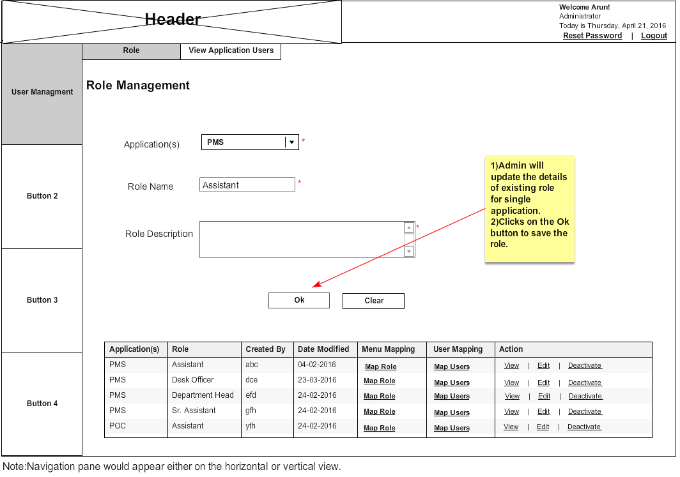

User Management- Admin-View Role

User Story ID | 0018
User Story Title | User Management- Admin- View details of a role
Actors | Admin
Story | As an Admin I want to view details of a role.
Pre-Conditions | Admin should be logged into the system.
Business Criteria | - Admin cannot create another admin user or role.  - Only those applications should be visible in creating a role for which the admin has access rights.  - Menu mapping of roles doesn’t include user management menus. Alternatively, admin would not be able to give access for user management to other users.  - In case an application has more than one admin then, any roles or users created by one admin would be displayed to all admins of the application.  - In case an application has more than one admin then, all admins would have same rights on users and roles of the application.  - One user will have one role in an application.  - A user can be given access for multiple applications.  - Admin would see the users of its application(s) along with the roles.
Acceptance criteria | - Admin click on ‘view’ option for a role from the list of options available in the grid and all information about the role will be displayed in a popup window.  - Application.  - Role Name.  - Role description.  - User would click on ‘OK’ button and flow will return to the ‘Roles’ tab.
Field level Validations | N/A

Mock-ups

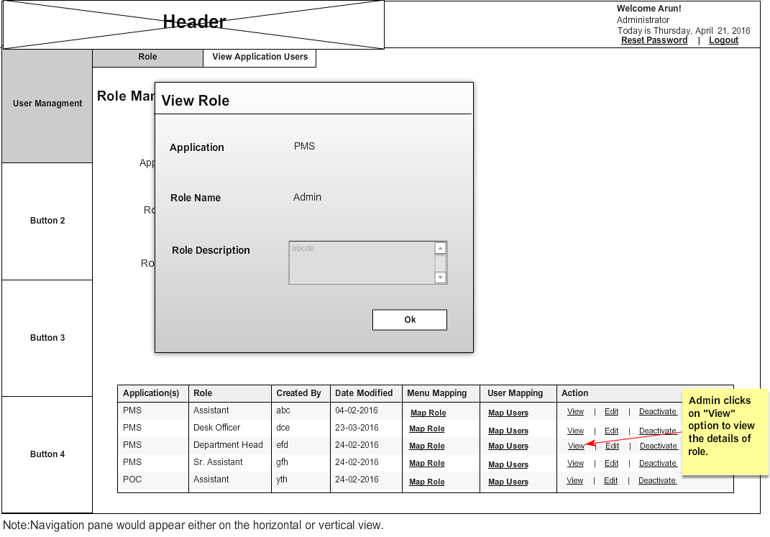

User Management- Admin- Deactivate/Activate a role

User Story ID | 0019
User Story Title | User Management- Admin- Deactivate/Activate a role
Actors | Admin
Story | As an Admin I want to activate/deactivate a role.
Pre-Conditions | Admin should be logged into the system.
Business Criteria | - Admin cannot create another admin user or role.  - Only those applications should be visible in creating a role for which the admin has access rights.  - Menu mapping of roles doesn’t include user management menus. Alternatively, admin would not be able to give access for user management to other users.  - In case an application has more than one admin then, any roles or users created by one admin would be displayed to all admins of the application.  - In case an application has more than one admin then, all admins would have same rights on users and roles of the application.  - One user will have one role in an application.  - A user can be given access for multiple applications.  - Admin would see the users of its application(s) along with the roles.
Acceptance criteria | - Admin would select ‘Activate/Deactivate’ option to activate or deactivate a role from the list of options available in the grid.  - Admin would click on ‘Activate’ option to activate role and ‘Deactivate’ option to deactivate the role. If a role is activated then ‘Deactivate’ option should be displayed and vice versa.
Field level Validations | N/A

Mock-ups

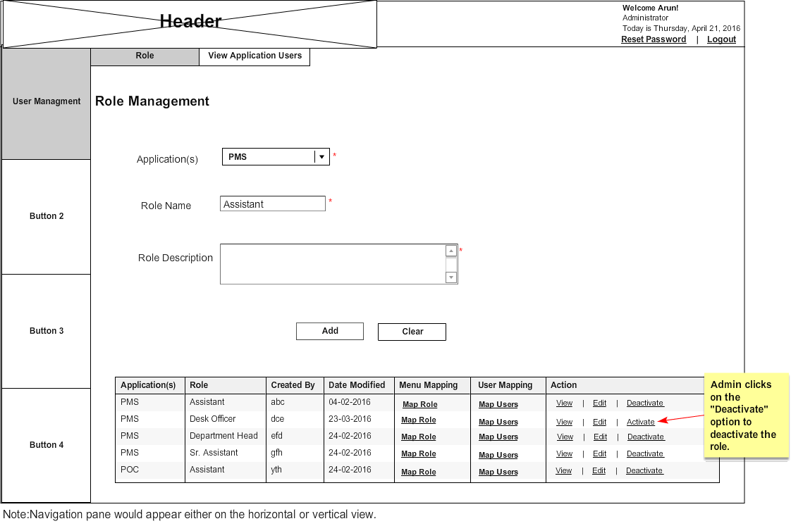

User Management- Admin-Map role

User Story ID | 0020
User Story Title | User Management- Admin- Map a role
Actors | Admin
Story | As an Admin I want to do menu mapping of a role
Pre-Conditions | Admin should be logged into the system.
Business Criteria | - Admin cannot create another admin user or role.  - Only those applications should be visible in creating a role for which the admin has access rights.  - Menu mapping of roles doesn’t include user management menus. Alternatively, admin would not be able to give access for user management to other users.  - In case an application has more than one admin then, any roles or users created by one admin would be displayed to all admins of the application.  - In case an application has more than one admin then, all admins would have same rights on users and roles of the application.  - One user will have one role in an application.  - A user can be given access for multiple applications.  - Admin would see the users of its application(s) along with the roles.
Acceptance criteria | - Admin would select ‘map role’ option from the list of options available in the grid to do menu mapping of a particular role. Once admin click on ‘map role’ option a screen should be displayed with a form which contains:  - A dropdown for selecting roles. By default this will be the selected role from the grid which can be further changed to menu map other roles.  - A list of menus, sub menus of the application (associated with the role) along with four checkbox options for the access rights:  - Read  - Write  - Modify  - Delete  - Applications, menus and submenus would be displayed in a hierarchal manner so that if admin provides particular access right on a superset then all subsets will be automatically checked for the respective access right as per the hierarchy. If any of the subset is unchecked then the superset will automatically be unchecked.  - Admin would provide the desired access rights by checking /unchecking the checkboxes of, Menus and Submenus.  - Once Admin maps the role he would click on ‘Submit’ button to complete the step or alternatively ‘cancel’ button to cancel the step. In both the cases control would return to ‘users’ tab.
Field level Validations | N/A

Mock-ups

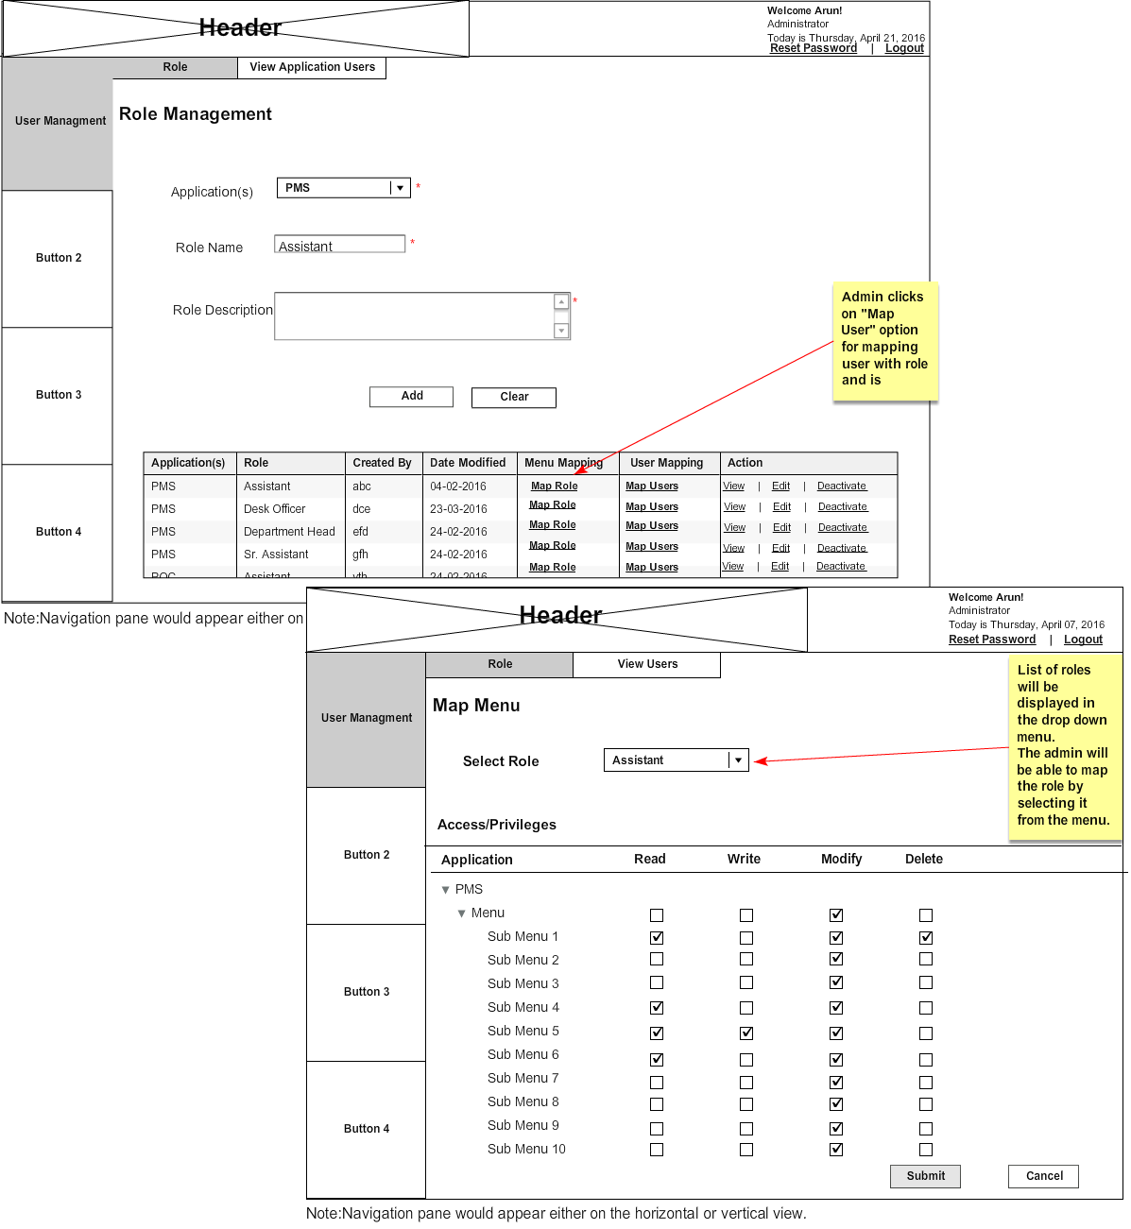

User Management- Admin-Map users

User Story ID | 0021
User Story Title | User Management- Admin- Map users
Actors | Admin
Story | As an Admin I want to map users to a role
Pre-Conditions | Admin should be logged into the system.
Business Criteria | - Admin cannot create another admin user or role.  - Only those applications should be visible in creating a role for which the admin has access rights.  - Menu mapping of roles doesn’t include user management menus. Alternatively, admin would not be able to give access for user management to other users.  - In case an application has more than one admin then, any roles or users created by one admin would be displayed to all admins of the application.  - In case an application has more than one admin then, all admins would have same rights on users and roles of the application.  - One user will have one role in an application.  - A user can be given access for multiple applications.  - Admin would see the users of its application(s) along with the roles.
Acceptance criteria | - Admin would select ‘map users’ option from the list of options available in the grid to do user mapping of a particular role.  - Once admin click on ‘map users’ option a screen should be displayed, which contains:  - All users in a grid with ‘add’ option  - A dropdown for selecting roles. By default this will be the selected role from the map user grid which can be further changed to other roles  - Grid for users, mapped to a role  - All users grid will display the following information for the user:  - Employee Id/User Name  - First Name  - Last Name  - Mobile  - Email  - Department  - Created by  - Last Modified  - Action ‘Add’  - Organizational Admin would click on the ‘Add’ option from the grid to map user to this role.  - All mapped users for this role will be displayed in a grid which contains following information:  - Employee Id/User Name  - First Name  - Last Name  - Mobile  - Email  - Department  - Created by  - Last modified  - Action ‘Remove’  - Admin can click on the ‘Remove’ option from the grid to un-map/remove the respective user from the list for this particular role.
Field level Validations

Mock-ups

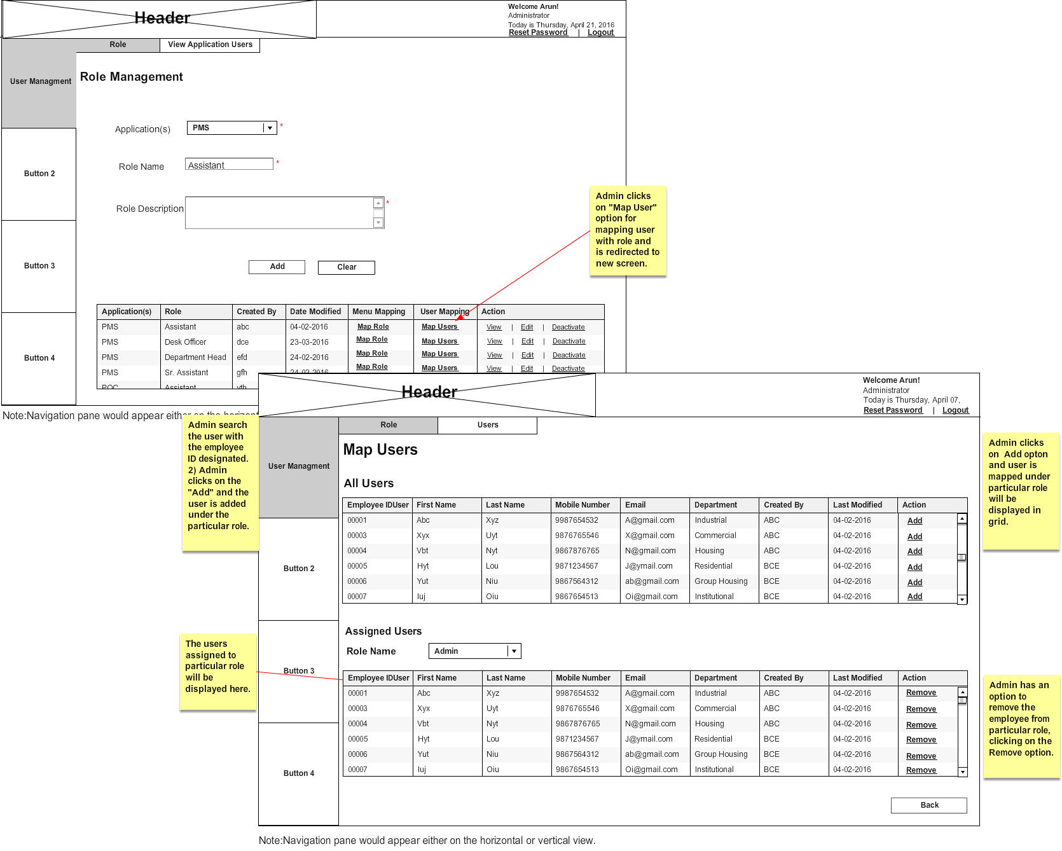

User Management- Admin-View Application users

User Story ID | 0011
User Story Title | User Management- Admin- View list of application users.
Actors | Admin
Story | As an Admin I want to view list of application users.
Pre-Conditions | Admin should be logged into the system.
Business Criteria | - Admin cannot create another admin user or role.  - Only those applications should be visible in creating a role for which the admin has access rights.  - Menu mapping of roles doesn’t include user management menus. Alternatively, admin would not be able to give access for user management to other users.  - In case an application has more than one admin then, any roles or users created by one admin would be displayed to all admins of the application.  - In case an application has more than one admin then, all admins would have same rights on users and roles of the application.  - One user will have one role in an application.  - A user can be given access for multiple applications.  - Admin would see the users of its application(s) along with the roles.
Acceptance criteria | - Admin click on ‘Application users’ tab under user management. Admin will get the list (grid) which contains the following columns with user information:  - Application (name of associate application)  - Role (name of role)  - Employee ID (employee id of user associated with the role)  - First Name  - Last Name  - Created By  - Date Modified  - Action: ‘view user’ , ‘Revoke/Grant’
Field level Validations | N/A

Mock-ups

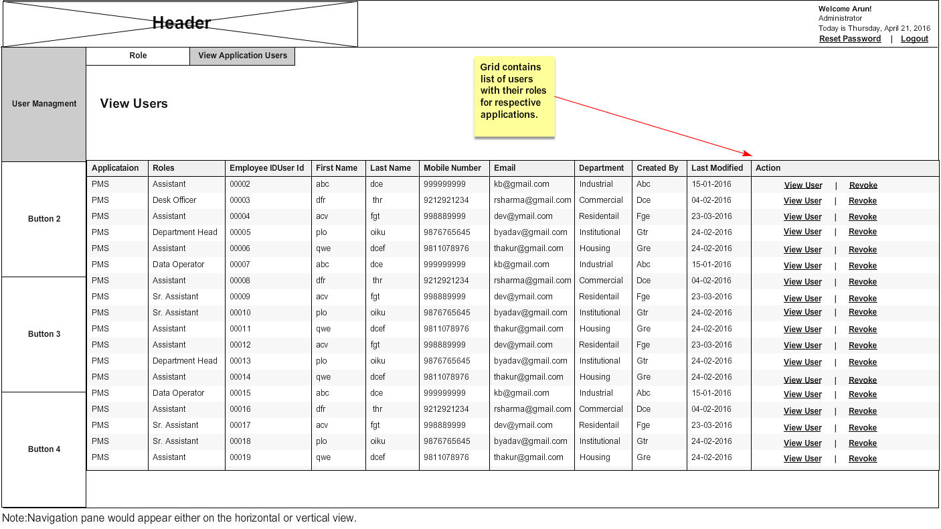

User Management- Admin-View user

User Story ID | 0023
User Story Title | User Management- Admin- View details of a user.
Actors | Admin
Story | As an Admin I want to view details of a user.
Pre-Conditions | Admin should be logged into the system.
Business Criteria | - Admin cannot create another admin user or role.  - Only those applications should be visible in creating a role for which the admin has access rights.  - Menu mapping of roles doesn’t include user management menus. Alternatively, admin would not be able to give access for user management to other users.  - In case an application has more than one admin then, any roles or users created by one admin would be displayed to all admins of the application.  - In case an application has more than one admin then, all admins would have same rights on users and roles of the application.  - One user will have one role in an application.  - A user can be given access for multiple applications.  - Admin would see the users of its application(s) along with the roles.
Acceptance criteria | - Admin click on ‘view user’ option for a user from the list of options available in the grid and all information about the user will be displayed in a popup window.  - Employee/User ID (auto generated, unique).  - First Name.  - Middle Name.  - Last Name.  - Department.  - Mobile number.  - Email.  - Comment.  - User would click on ‘OK’ button and flow will return to the ‘Users’ tab.
Field level Validations | N/A

Mock-ups

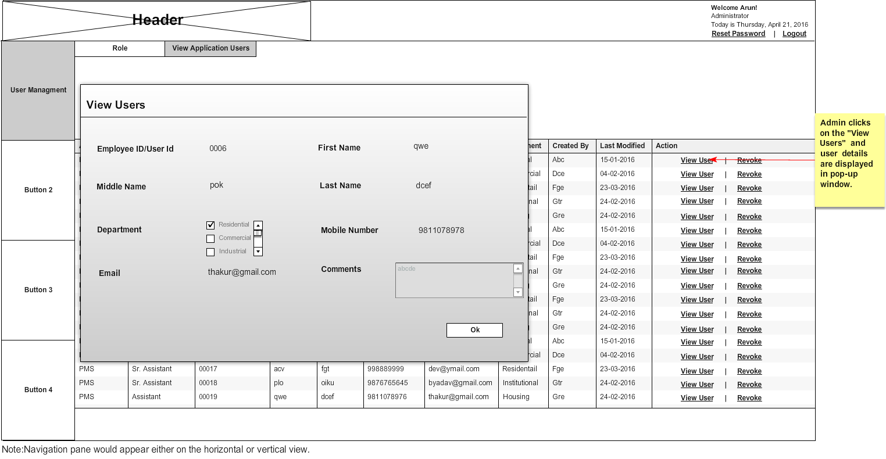

User Management- Admin-Revoke/Grant role to user

User Story ID | 0024
User Story Title | 1.User Management- Admin-Revoke/Grant role to user
Actors | Admin
Story | As an Admin I want to grant or revoke a role to a user.
Pre-Conditions | Admin should be logged into the system.
Business Criteria | - Admin cannot create another admin user or role.  - Only those applications should be visible in creating a role for which the admin has access rights.  - Menu mapping of roles doesn’t include user management menus. Alternatively, admin would not be able to give access for user management to other users.  - In case an application has more than one admin then, any roles or users created by one admin would be displayed to all admins of the application.  - In case an application has more than one admin then, all admins would have same rights on users and roles of the application.  - One user will have one role in an application.  - A user can be given access for multiple applications.  - Admin would see the users of its application(s) along with the roles.
Acceptance criteria | - Admin would select ‘Revoke/Grant’ option to revoke or grant a role to user from the list of options available in the grid.  - Admin would click on ‘Revoke’ option to revoke a role and ‘Grant’ option to grant a role to user. If a role is granted then ‘Revoke’ option should be displayed and vice versa.
Field level Validations | N/A

Mock-ups

